**SQL Joins & Relations**

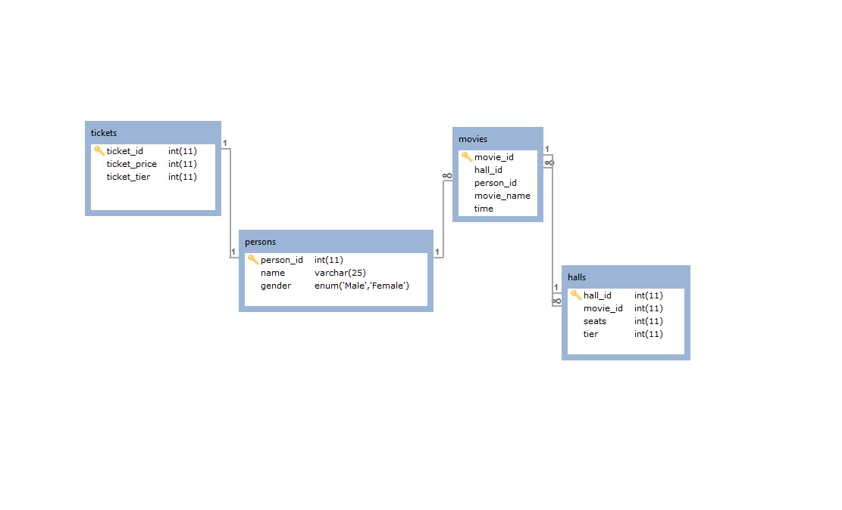

**Query #1**

SELECT tickets.ticket_id, persons.person_id FROM tickets

INNER JOIN persons ON tickets.ticket_id = persons.person_id;

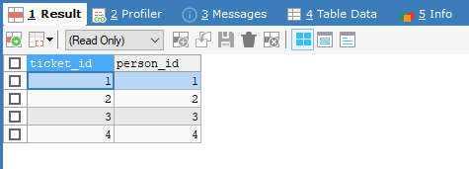

**Query #2**

SELECT tickets.`ticket_tier`, persons.`name` FROM tickets, persons

WHERE tickets.ticket_id = persons.person_id;

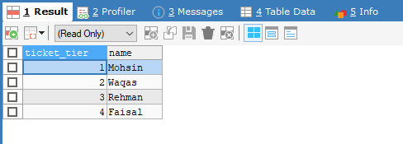

**Query #3**

SELECT * FROM tickets JOIN persons

ON tickets.ticket_id = persons.person_id;

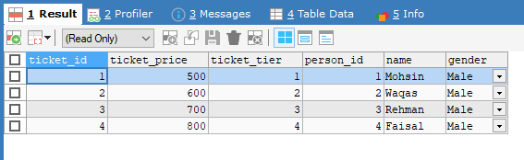

**Query #4**

SELECT * FROM movies JOIN persons USING (person_id);

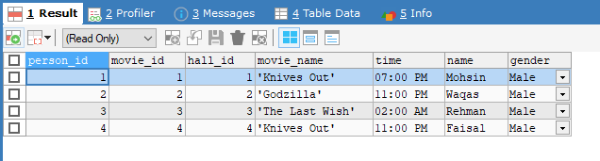

**Query #5**

SELECT persons.name, movies.`movie_name` FROM persons NATURAL JOIN movies;

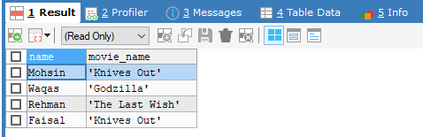

**Query #6**

SELECT persons.name, persons.`gender`, movies.`movie_name`,

movies.`time` FROM persons LEFT JOIN movies

ON persons.person_Id = movies.person_Id;

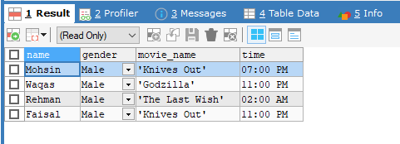

**Query #7**

SELECT persons.name, movies.`time` FROM persons RIGHT JOIN movies

ON persons.person_Id = movies.person_Id;

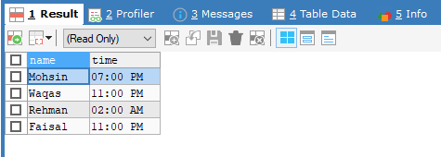

**Query #8**

SELECT * FROM tickets CROSS JOIN movies;

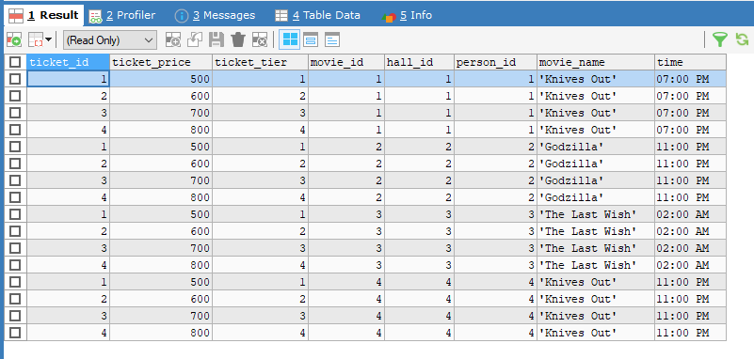

**Query #9**

SELECT m.`tier` AS 'Hall Tier', h.`seats` AS 'Hall Seats' FROM halls m, halls h

WHERE m.movie_id = h.movie_id;

